**Applet**

**Applet** is a predefined class in **java.applet** package used to design distributed application. It is a client side technology. Applets are run on web browser.

**Advantage of Applet**

* Applets are supported by most web browsers.
* Applets works at client side so less response time.
* **Secured:**No access to the local machine and can only access the server it came from.
* Easy to develop applet, just extends applet class.
* To run applets, it requires the Java plug-in at client side.
* Android, do not run Java applets.
* Some applets require a specific JRE. If it required new JRE then it take more time to download new JRE.

**Life cycle of applet**

* init()
* start()
* stop
* destroy

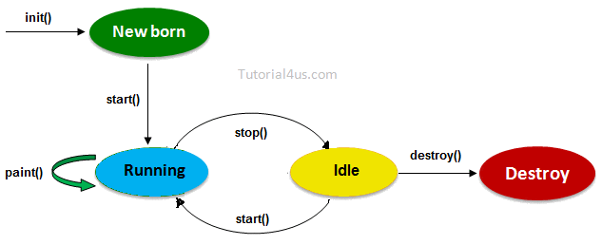

**init():**Which will be executed whenever an applet program start loading, it contains the logic to initiate the applet properties.

**start():**It will be executed whenever applet program starts running.

**stop():**Which will be executed whenever applet window or browser is minimized.

**destroy():**It will be executed whenever applet window or browser is going to be closed (at the time of destroying the applet program permanently).

**Design applet program**

We can design our own applet program by extending applet class in the user defined class.

**Syntax**

**class** className **extends** Applet

{

......

// override lifecycle methods

......

}

**Note:**Whenever an applet program is running inti() and start() will be executed one after another but stop() and destroy() will be executed if the browser is minimized and closed by the end user respectively.

**Note:**Applet program may or may not contain life cycle methods.

**Running of applet programs**

Applet program can run in two ways.

* Using html (in the web browser)
* Using appletviewer tool (in applet window)

**Running of applet using html**

In general no java program can directly execute on the web browser except markup language like html, xml etc.

Html support a predefined tag called <applet> to load the applet program on the browser window.

**Syntax**

**<applet** code="udc.class"**>**

height="100px"

width="100px"

**</applet>**

**Example of applet program to run applet using html**

**Java code, JavaApp.java**

**import** java.applet.*;

**import** java.awt.*;

**public** **class** JavaApp **extends** Applet

{

**public** **void** paint(Graphics g)

{

Font f=**new** Font("Arial",Font.BOLD,30);

g.setFont(f);

setForeground(Color.red);

setBackground(Color.white);

g.drawString("Student",200,200);

}

}

**Html code, myapplet.html**

**<html>**

**<title>** AppletEx**</Title>**

**<body>**

**<applet** code="JavaApp.class"

height="70%"

width="80%"**>**

**</applet>**

**</body>**

**</html>**

**Running of applet using appletviewer**

Some browser does not support **<applet>** tag so that Sun MicroSystem was introduced a special tool called **appletviewer** to run the applet program.

In this Scenario java program should contains <applet> tag in the commented lines so that appletviewer tools can run the current applet program.

**Example of Applet**

**import** java.applet.*;

**import** java.awt.*;

/*<applet code="LifeApp.class" height="500",width="800">

</applet>*/

**public** **class** LifeApp **extends** Applet

{

String s= " ";

**public** **void** init()

{

s=s+ " int ";

}

**public** **void** start()

{

s=s+ "start ";

}

**public** **void** stop()

{

s=s+ "stop ";

}

**public** **void** destroy()

{

s=s+ " destory ";

}

**public** **void** paint(Graphics g)

{

Font f=**new** Font("Arial",Font.BOLD,30);

setBackgroundColor(Color."red");

g.setFont(f);

g.drawString(s,200,250);

}

}

**Execution of applet program**

javac LifeApp.java

appletviewer LifeApp.java